Pupils uploading documents
Pupils can now access the document in either their ‘My work' – the yellow folder or in the ‘shared folder’, this depends on the location that the teacher has saved it in.

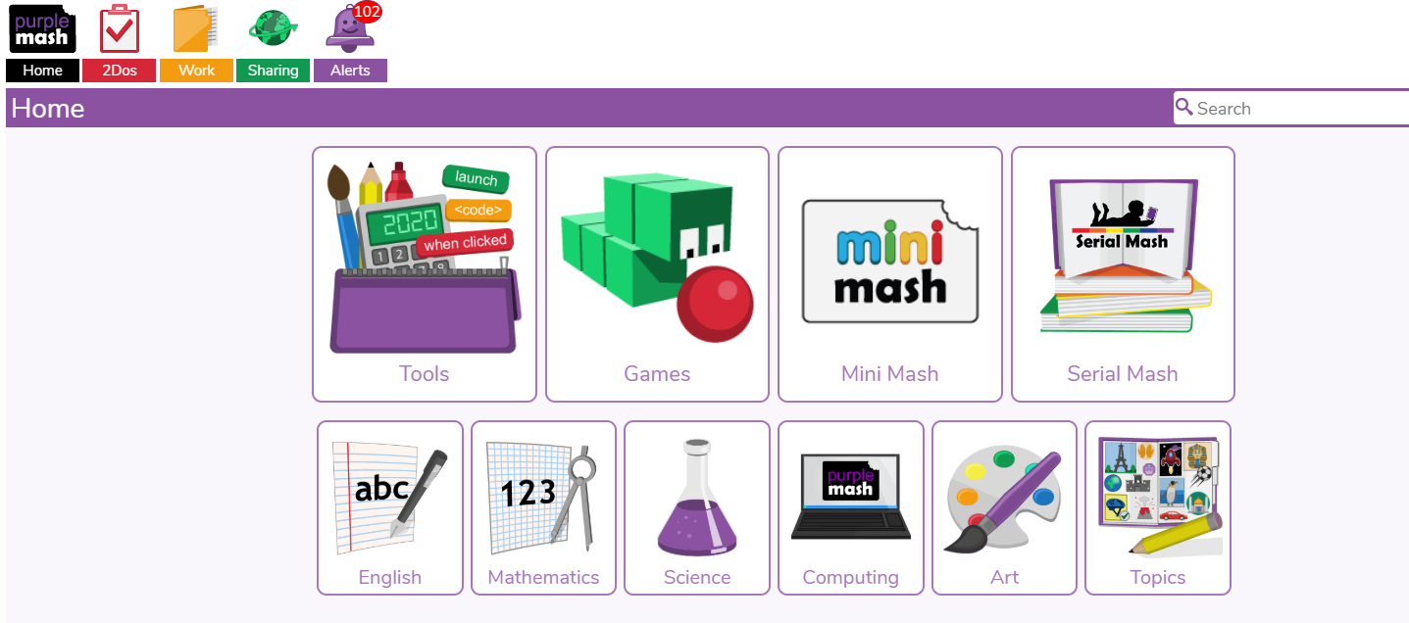
The pupil can open this file to work on it. • Pupils can now save that document and upload it back into their ‘My Work’ folder.

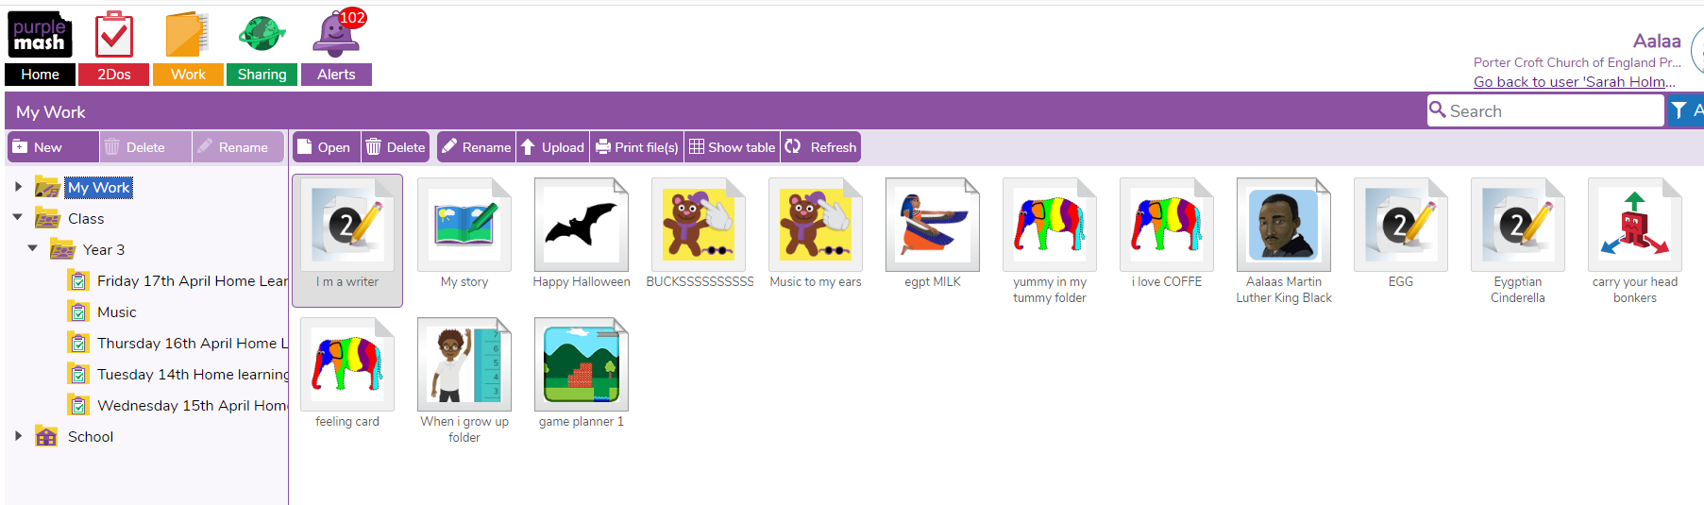
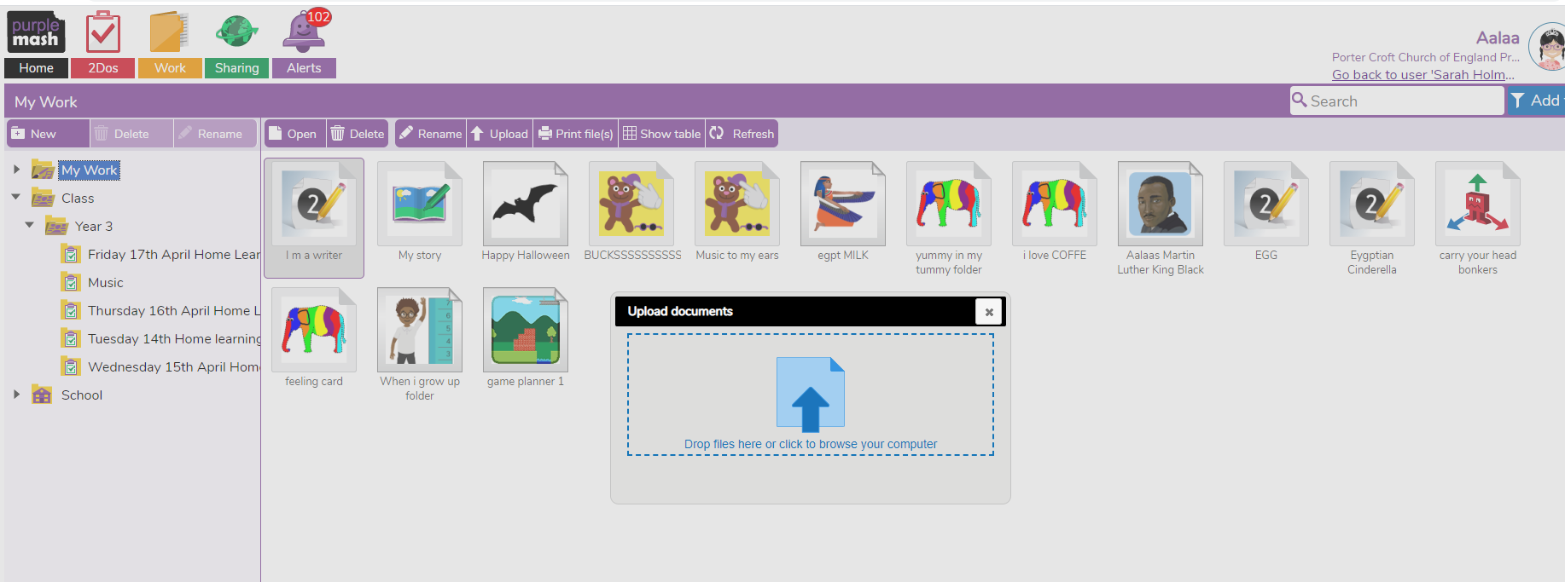

Uploading work onto blogs
Pupils can access the Blogs through clicking on the green world icon – sharing and going into shared blogs.
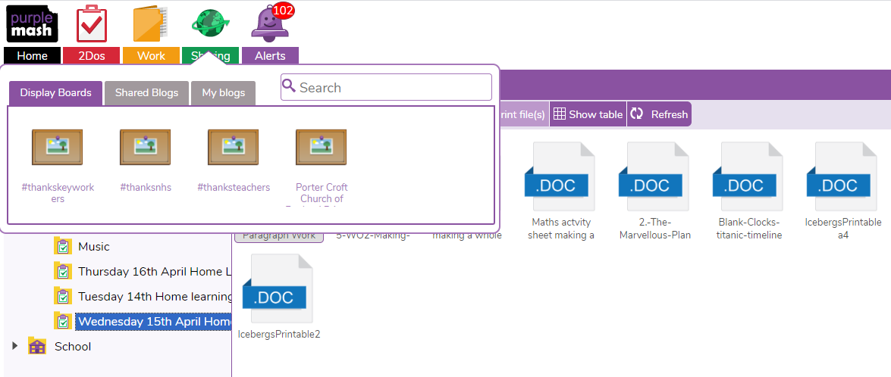
Pupils can then click on their year group class blog.
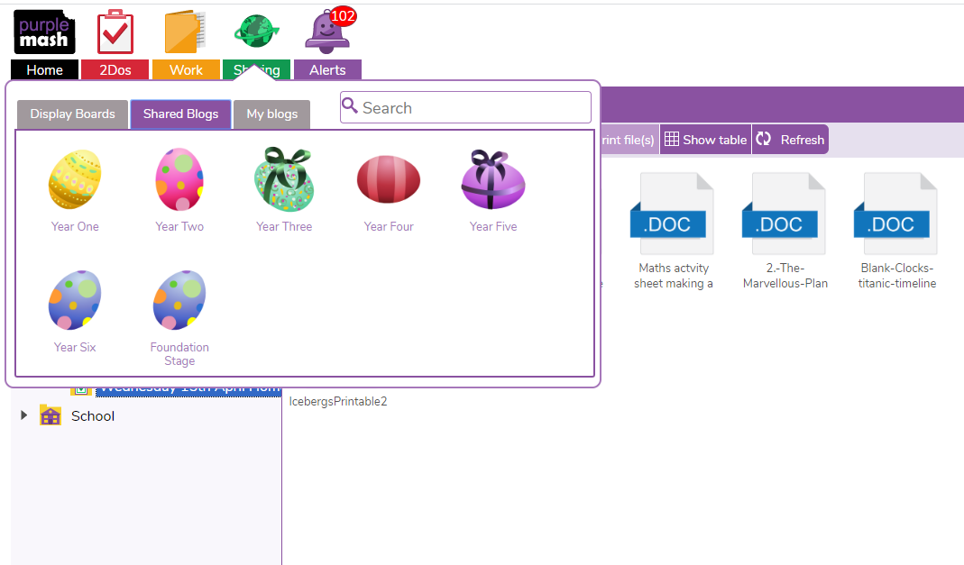
They can click on the learning link and this will open a blog page.
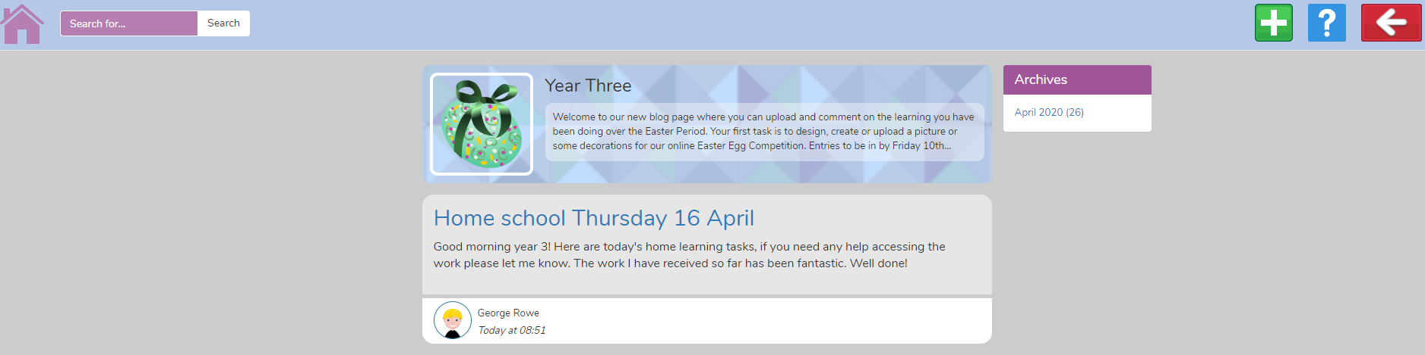
To comment or upload work onto the blog, children need to click on the green/white cross button on the top right.
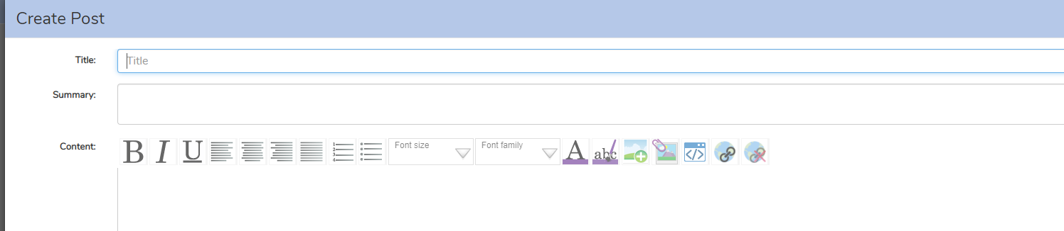
This will create a post, which allows children to write a message and upload work/photos by pressing on the picture button, which have a green cross or a picture with a paper clip on.
Teachers can see the posts and will approve these before the rest of the class can see them.

